**IFT 266 Introduction to Network Information Communication Technology (ICT)   
  
Lab 45**

**Understanding the different IPv6 subnet prefix lengths**

Co-authored by Ethan Rosenberg

**After you complete each step, double click on the “completed” box, answer the open question  
or**

**Attach a screenshot where required**

1. Setup the following topology in Packet Tracer

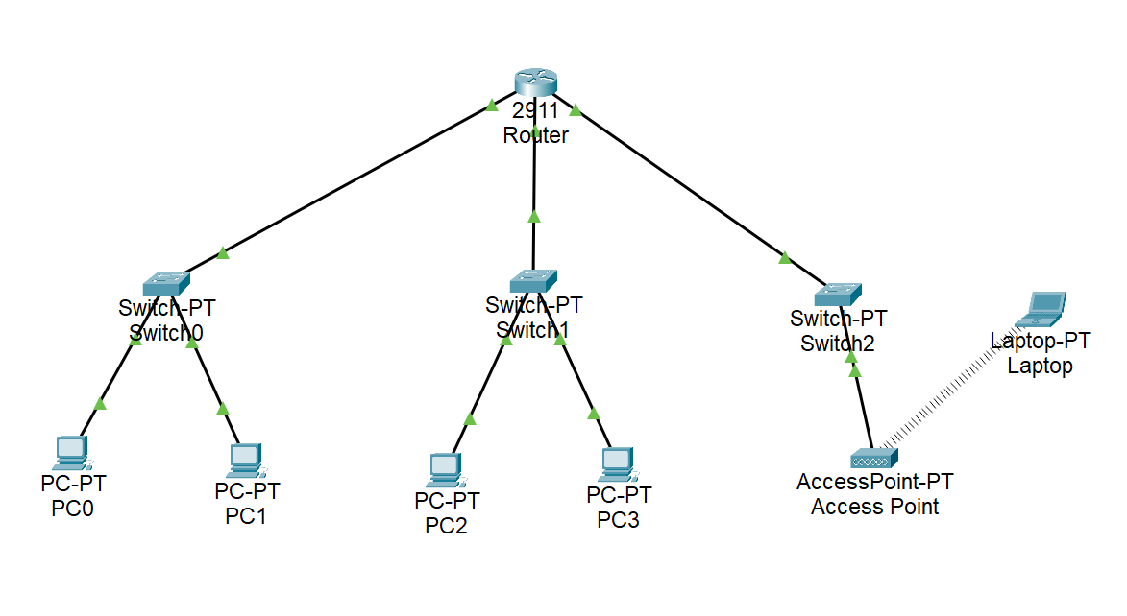

Completed  (Double click on Check box and select “Checked”)

1. Your ISP has assigned you the following IPv6 address: 2001:ACAD:1234:1200::/56  
     
    2001:ACAD:1234:12 → Global Routing Prefix or Site Prefix

00 → Two hexadecimal characters (8 bits) set aside for the subnet ID.

/56 indicates that only the last hexadecimal characters (00) in the fourth field will be used for subnets.

As per Slide 13 on presentation 17, the other common prefix lengths are /48, 52, 60 and 64.

**Question - Fill in the blanks**

/56 gives us a maximum amount of _______ subnets with ranges from 12__ (first subnet) → 12__ (last subnet).

Please provide the first three subnet ID’s here: _______, ________, and _________

1. You have now successfully listed the first three subnet ID’s (as per the open question in step 2).   
     
   Based on these three subnet IDs, using the notes option in packet tracer, add in the subnet prefix address for each subnet as demonstrated in the following image (this image is just an example) to your topology (that you created in step 1).

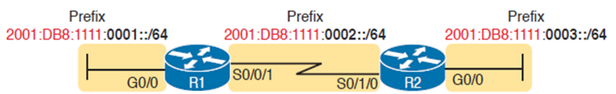

Insert an updated screenshot of your topology below with each subnet prefix note listed for each subnet.

1. We will now configure this IPv6 addressing scheme (that we designed in steps 2 and 3) on our packet tracer topology.

Enable IPv6 routing on a Cisco router using the ‘ipv6 unicast-routing’ global configuration command.  
  
On each interface (int Gi0/0 for example), you will enable IPv6 on the interface via the “enable IPv6” command then enter the command “ipv6 address 2001:ACAD:1234:12??::/64” (where ?? represents the value of the subnet ID that we listed in step 2) and then type ‘no shut’ command to enable the interface.  
  
Repeat these same configuration steps on each router connection (three routers connections for the three separate subnets).

Completed  (Double click on Check box and select “Checked”)

1. Now, go to each host device (PCs and the laptop) on each of the three networks and configure the device using SLAAC or the auto-configure option. Insert a screenshot of the laptop’s IPv6 configuration details below.

1. PC1 should now be able to ping the laptop. Insert a screenshot of the successful ping below.



We enter the command “ipv6 address 2001:ACAD:1234:12??::/56” rather than “ipv6 address 2001:ACAD:1234:12??::/64” on each of the router interfaces with the appropriate subnet ID?

Remove all IPv6 allocations by typing “no ipv6 address” in all the interfaces on the Router CLI. Re-configure all the interfaces with the ::/56 prefix and then use SLAAC configuration for all the host devices.

Try it out and insert a screenshot of the error that you get below.

1. Even though our ISP assigned us a /56 block, the correct subnet prefix that we would configure on the router interfaces would be /64.   
     
   Think about it this way, we assigned the first router interface the address of 2001:ACAD:1234:1201::/64 (remember, not a good idea to assign 00).  
     
   We received the Global Routing Prefix (2001:ACAD:1234:12) from our ISP and then assigned the subnet ID’s starting at 00 (so it would be 1200), 01 (1201) and so on till FF (12FF).

The router interface now has now been assigned a subnet and will have its own IP address → 2001:ACAD:1234:1201::1/64 as an example.

When a host device uses SLAAC to configure its GUA, it will take the Global Routing Prefix and subnet ID from that router interface and create its own host portion of the address.

Completed  (Double click on Check box and select “Checked”)

**Extra Credit (100 points)**

In the original topology, we used a separate layer-two switch for each of the networks, three switches in total.

I want you now to redesign the topology and only use one layer two switch. You will need to configure VLANS on the switch to create the different subnets.

Insert a screenshot of the updated topology below.  
**(Please rename the singular switch to your ‘last name’)**

Insert a screenshot of the successful ping between any PC and the laptop below.